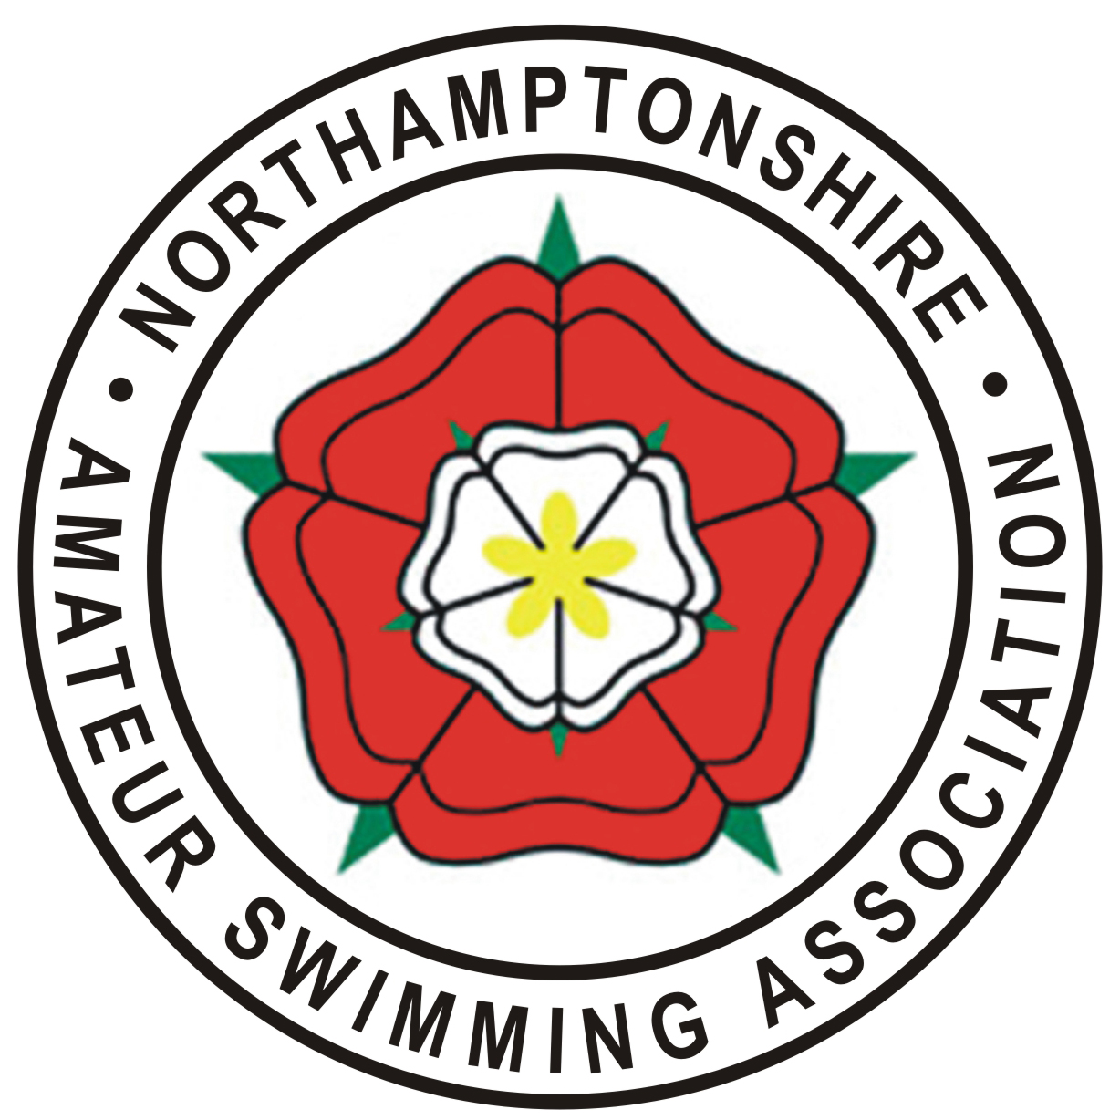

Northamptonshire Amateur Swimming Association
(Affiliated to Swim England East Midlands Region)

To the Parents/Guardians of all swimmers born 2008 and the Parents/Guardians of 2005-2007 born swimmers who are competing at this County Championships for the first time.

Northants ASA would like to invite you to attend a Workshop on Saturday 9th February.

The workshop will have 3 key themes:
- The Daily Training Environment
- The Competition Pathway
- The Development Programme

The aim of the workshop is to expand awareness of the opportunities available to swimmers beyond their Club environment and how to achieve progression along the ‘Pathway’.

Northamptonshire ASA has always supported The ASA’s development programmes and was among the 18 Counties who first implemented the new Swim England Pathway in 2017. (There are 33 Counties in England if you were wondering.) 2019 is our 3rd year of delivering the new programme.

The Swim England Pathway requires Counties to hold 3 x 1 day camps for swimmers aged 11 at 31/12 in the year of competition. These are lead by a Head Coach, selected from within the County and supported by Skills Coaches and Team Managers engaged by NASA from within the County.
For the 2019 camps, the swimmers will be selected after our County Championships have finished, according to the selection policy issued by Swim England.

Please do come along and support your Swimmer & County.

Date: Saturday 9th February

Time: 12.10 pm (Workshop should last approx. 60 mins)

Where: Council Chambers, The Cube, Corby

Seating is limited and we ask, where possible, that just 1 Parent/Guardian per swimmer attends.

Please could you email Marilyn Richmond if you will be attending as this will help us with accommodating all attendees.

If you have any questions regarding this workshop, please contact the undersigned.

Marilyn Richmond
Northamptonshire ASA’s Pathway Programme Lead
maz.nasa@hotmail.co.uk

